**Challenges on flowcharts**

Draw a flowchart to enter integers between 5 and 20 until their sum is greater than 200. Display how many were entered.

**Challenge 2**

Problem: Develop an application that will allow a customer to pay his parking ticket at a shopping mall. The customer will enter his ticket into a ticket machine. This machine consists of a card reading module that determines how long the car has been parked. This value (parking duration in minutes) is sent to the ticket application to determine the amount due and to print a receipt after the customer has paid. For our purposes you may assume that the total minutes supplied will be entered into a text box. The amount due will then be calculated as follows:

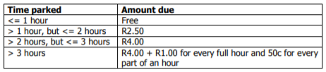

If the customer parked for free, his time and a suitable message must be displayed on the label (that serves as a receipt). E.g. You parked for only 45 minutes Your parking is free If the parking is not for free, the amount due must be displayed on a message box and the user must then enter every amount paid into an input box until the total amount paid is more or equal to the amount due. After every amount has been entered into the input box, the total amount paid and remaining amount due (if any) must be displayed in a message box. When the full amount has been paid, the amount due, total paid and change (if any) must be displayed on the label to serve as a receipt.

E.g.

Total amount due: R8.50

First amount paid: R5

Message: You paid R5.00.

You still need to pay R3.50

Next amount paid: R2

Message: You paid R7.00.

You still need to pay R1.50

Next amount paid: R2

Receipt (displayed on label)

You parked for 7 hours and 20 minutes

Amount due for parking = R8.50

Amount paid = R9.00